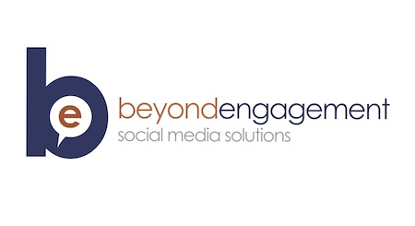 | Beyond Engagement  Valentina Escobar-Gonzalez, MBA  P.O. Box 5934  Johnson City, TN 37601  Ph. (423)-631-6102

Mrs. Jenny F Kontos
Kontos Creative
3103 Brown Mills Rd, Suite 6
Johnson City, TN 37604

8/14/15

Dear Jenny:

It was nice speaking with you about promoting Kontos Creative more effectively with social media. I have several suggestions to add consistency and visibility to your social platforms.

Why Invest in Social Media Marketing?

- Approximately 46% of online users count on social media when making a purchase decision. (Source: Nielsen)
- Social media produces almost double the marketing leads of trade shows, telemarketing, direct mail, or PPC. (Source: HubSpot)
- 25% of consumers who complain about products on Facebook or Twitter expect a response within 1 hour. (Source: American Express)

Using Social Media Platforms

Facebook:

Consistency and visuals are key to Facebook success. There are many ways to go about it, using visual enhancing tools like PicMonkey.com. I could teach you how to create or add visuals, engage with your fans, and respond to comments professionally.

The usage of Facebook advertisement is highly suggested since Facebook reach is about 6% or less. It should be closing in to zero percent by the end of 2015. If you have 100 fans (“likes”) only 6% will view your updates as of right now! Facebook ads could target a niche audience. For example, promote your Facebook post but selecting an audience like past clients or potential leads who have an expressed an interest in Small Business that like the local chamber that are Baby Boomers or Nonprofit Professionals. You can get very targeted in selecting your audience!

Instagram:

“Instagram delivered 58 times more engagement per follower than Facebook, and 120 times more engagement per follower than Twitter.” (Source: Forrester)

Tactics similar to Pinterest but more focus on adding hashtags based on keywords (i.e. outfit of the day #ootd), emotions, and location. It humanizes your brand!

Social Media Movement Training will include:

• Integration of social media outlets for distribution of content
• Maintaining social profiles updates in Facebook & Instagram
• Moderation of comments and content on these social platforms
• Creation of an audience in these communities
• Generation of traffic to the website from social media sites
• Increase brand awareness, promote engagement, and event
• Usage of social media to raise back-links to the main website

The Community Manager will provide reports with results of audience growth, engagement, keyword analysis, and suggested marketing happenings.

Compensation US $ DOLLARS

Hourly Consultation* $60/Hour

Plus costs of “promotion” or “boosting” of event through Facebook advertisement. Typical budgets range from $5-$15 per promoted post. This will be invoiced separately.

Outside Projects

The costs of any assignments above and beyond this proposal such as creation of website design, copy writing, development, hosting, domain registration, stock photography is not applicable.

About Valentina

Valentina Escobar-Gonzalez, MBA is an award winning young professional. She has a background in sales and has been using social media platforms professionally since 2009. Her experiences stems from years staying current on the latest in industry news, handling customer objectives, and creating a solid social media marketing plan.

Looking forward to starting this contract project for you and it’s social media presence. Please, contact if there are any questions regarding this proposal.

Sincerely,

M. Valentina Escobar-Gonzalez

M. Valentina Escobar-Gonzalez

